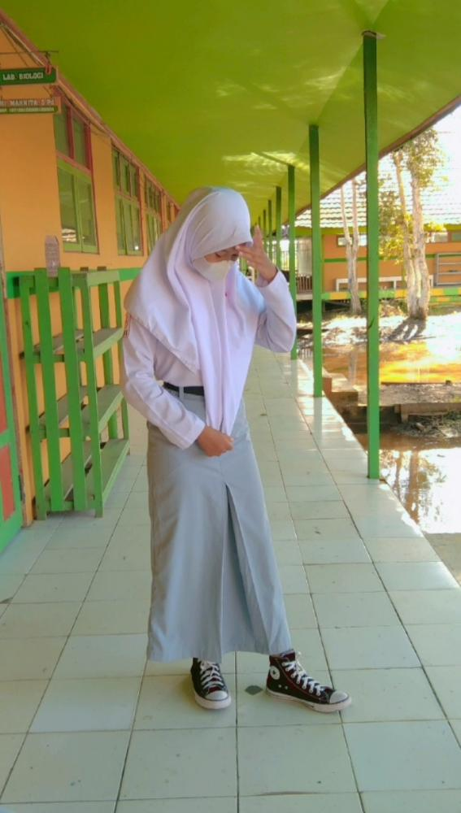

This photo was taken in August at which time each class was required to have to a representative to attend the 25th Anniversary of Smanjipa.